Update for 1/12/21:

* Continuing basic terrain shaping
* Continuing placing first buildings in bases and outpost

[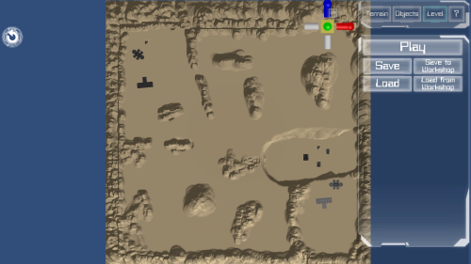](https://cdn.discordapp.com/attachments/465943118798389269/798629842702434304/unknown.png)

[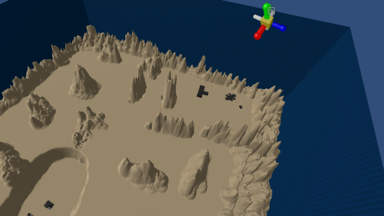](https://cdn.discordapp.com/attachments/465943118798389269/798630024223784960/unknown.png)

[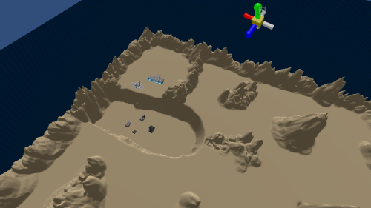](https://cdn.discordapp.com/attachments/465943118798389269/798630104246780005/unknown.png)

Update for 1/18/21:

* Created routes from bases to POIs.
* Will continue refining landscape as needed.
* Will start putting paint textures on landscape.

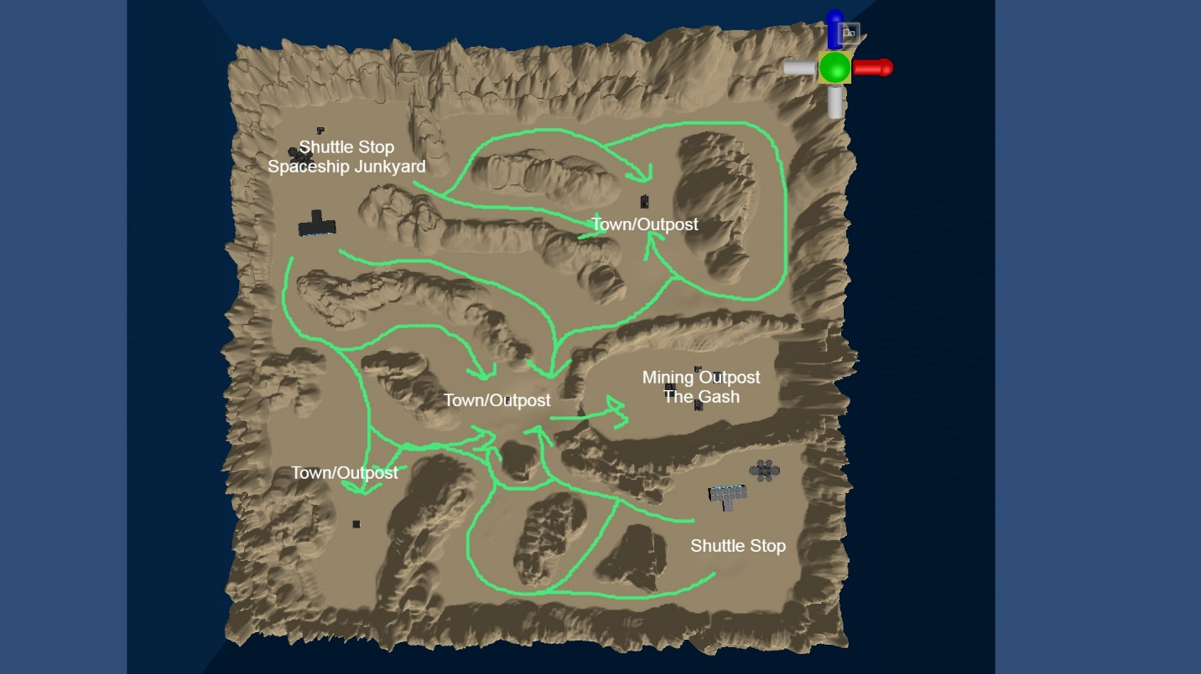

Update for 1/22/21:

WIP: Adding terrain assets to landscape and texturing landscape.

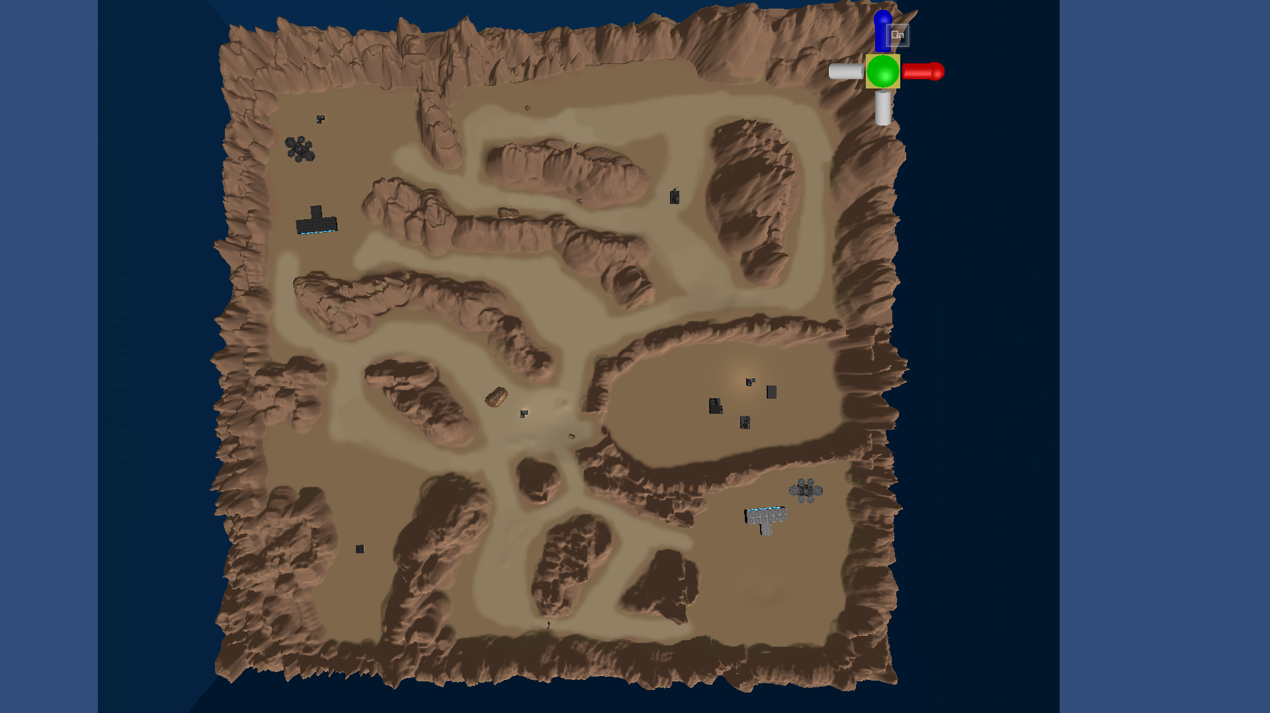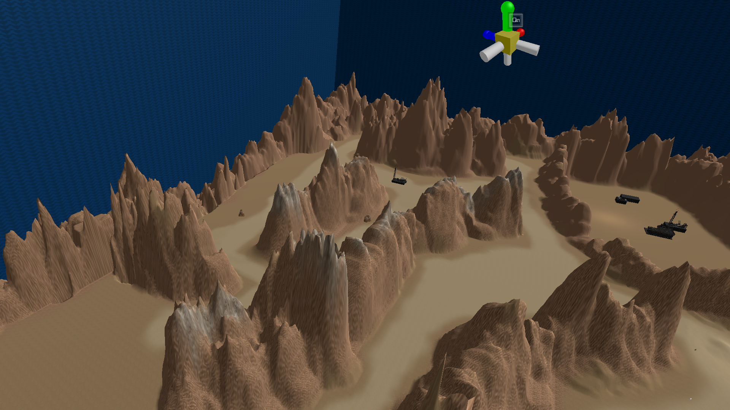Top of Form

Update for 1/26/21:

* Placing terrain assets throughout map
* Placed bunker entrances in trench (middle right) and one of the secondary outposts (lower left)
* Started placing assets in spaceship junkyard

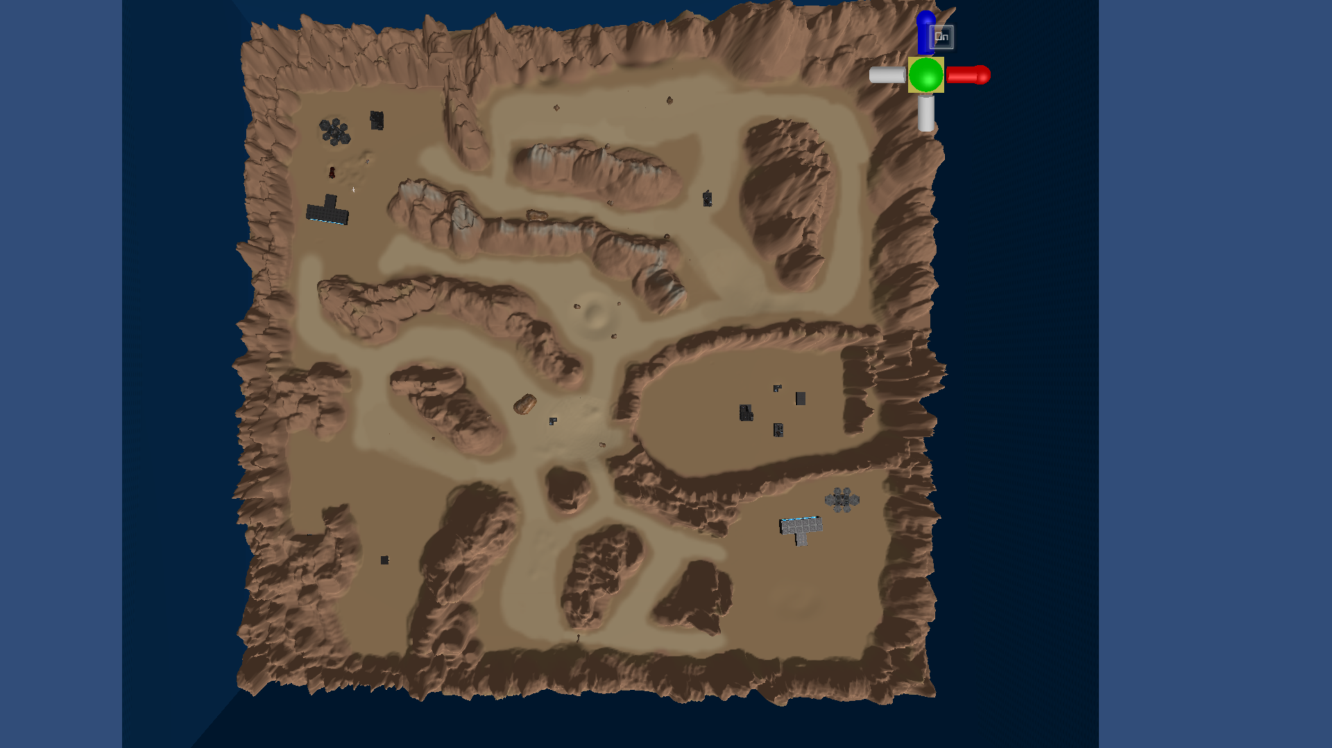

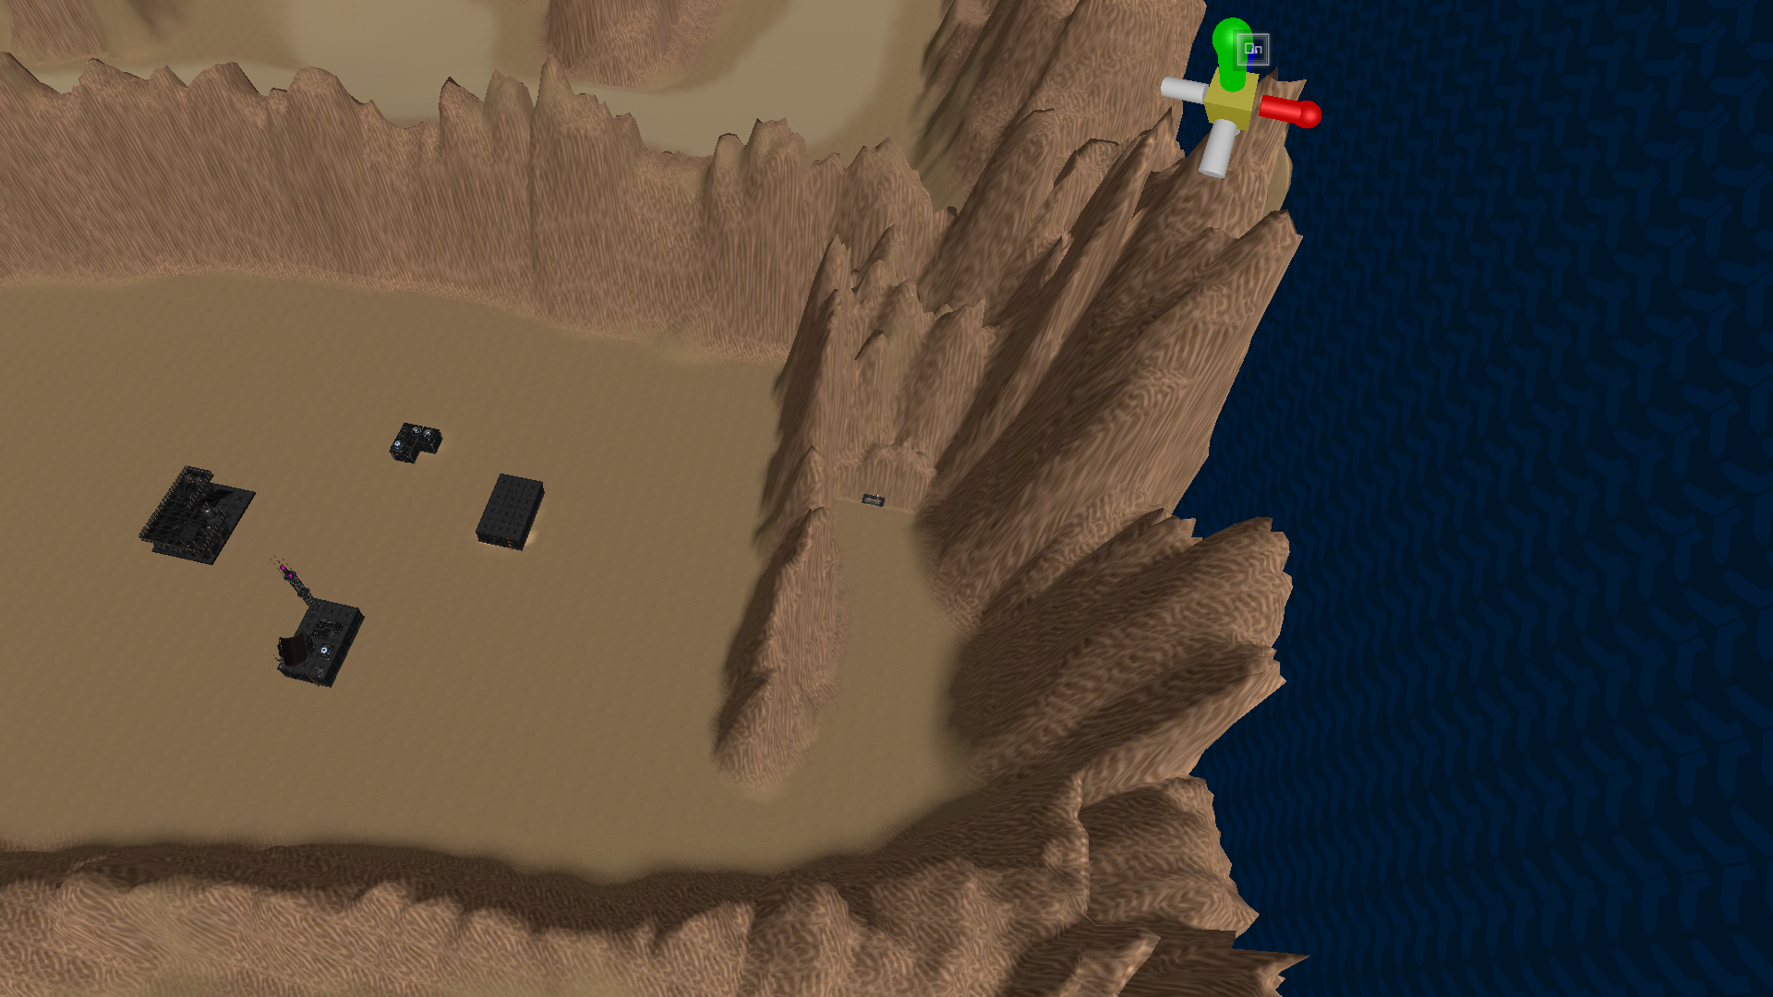

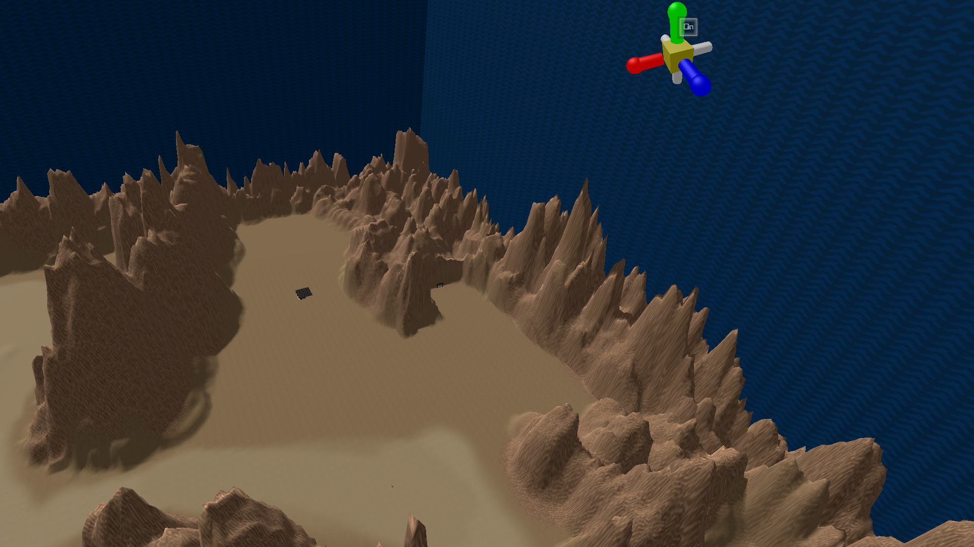

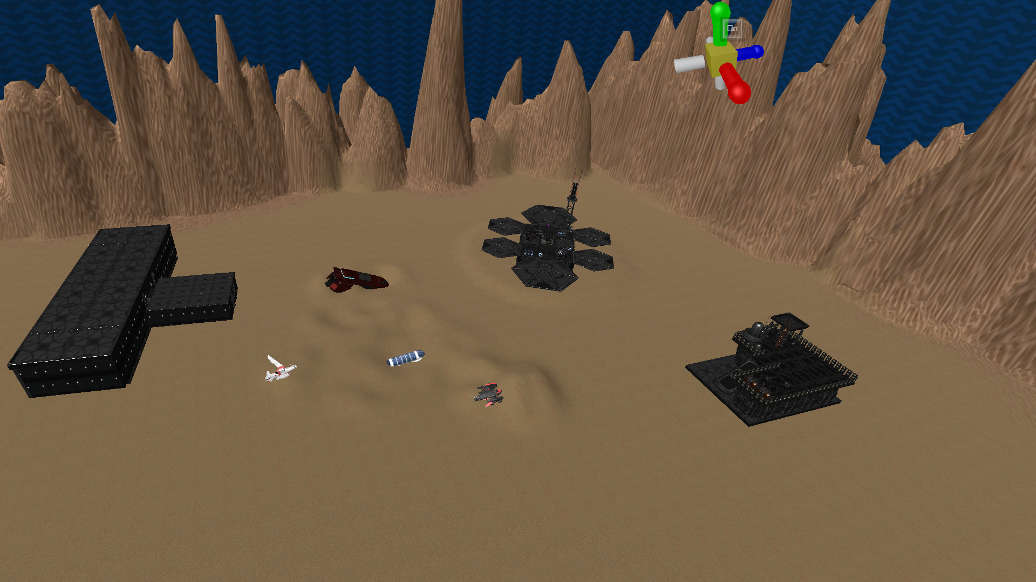

Update for 1/28/21:

* In Spaceship Junkyard, switching buildings to older, worn down models to better fit junkyard theme
* Erecting wall around some parts of junkyard
* Added basic ramp for access to trench
* Started adding run down buildings to lower left abandoned town.
* Collision detection on ships not working (messaged programming lead)
* Will continue placing ships in scene once collision issue is resolved

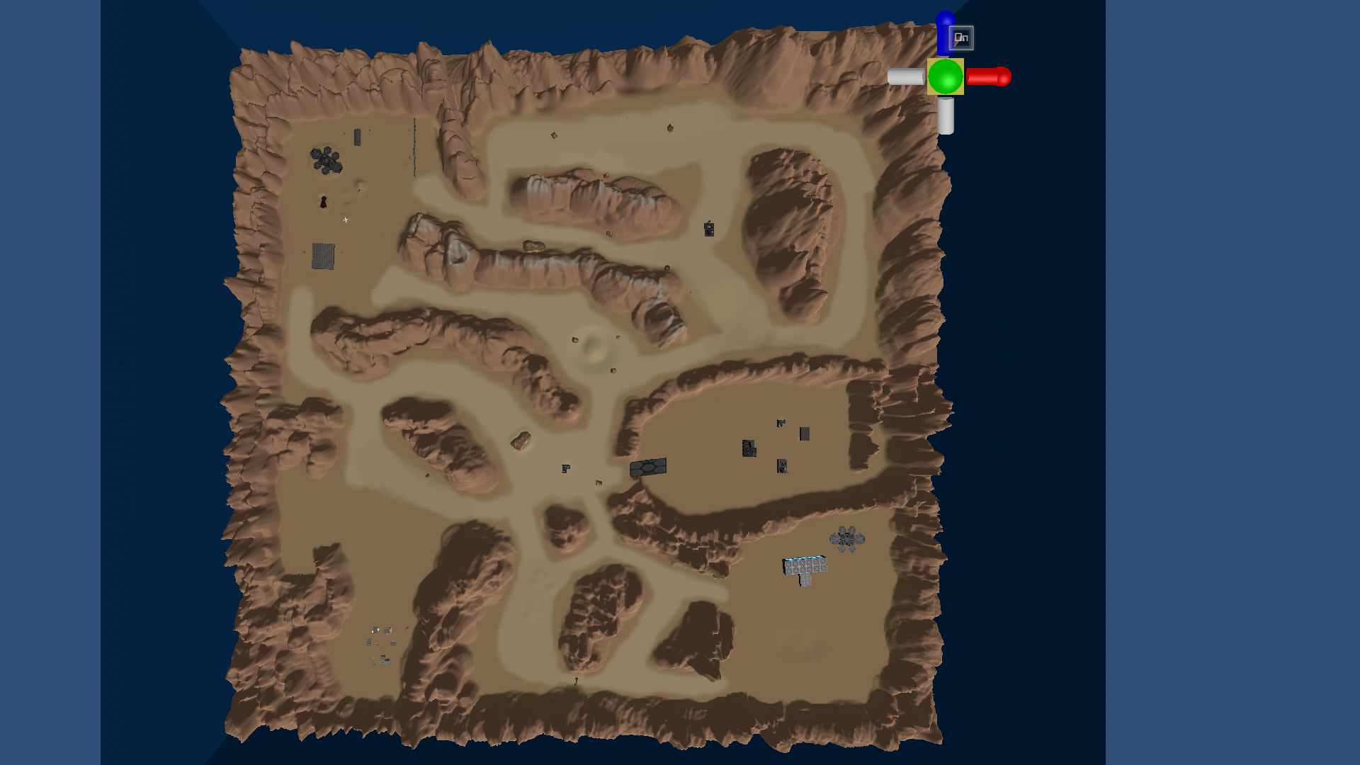

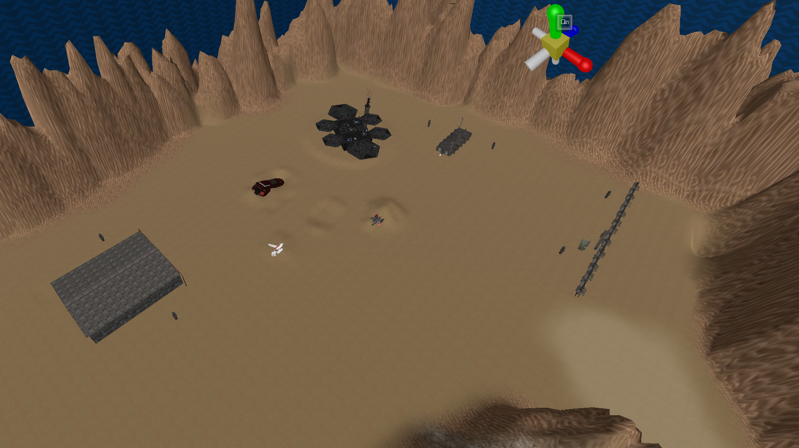

Update for 2/2/21:

* Continued placing ships and natural terrain assets into scene
* Continued work on junkyard and central POI.
* Touching up several parts of the map

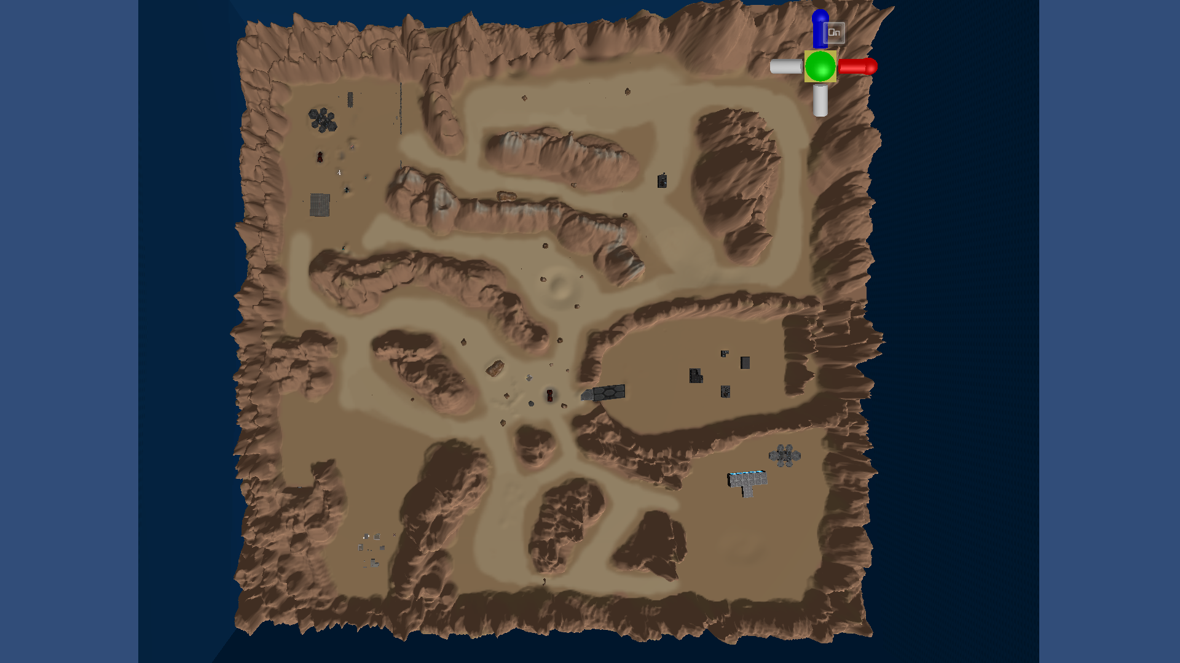

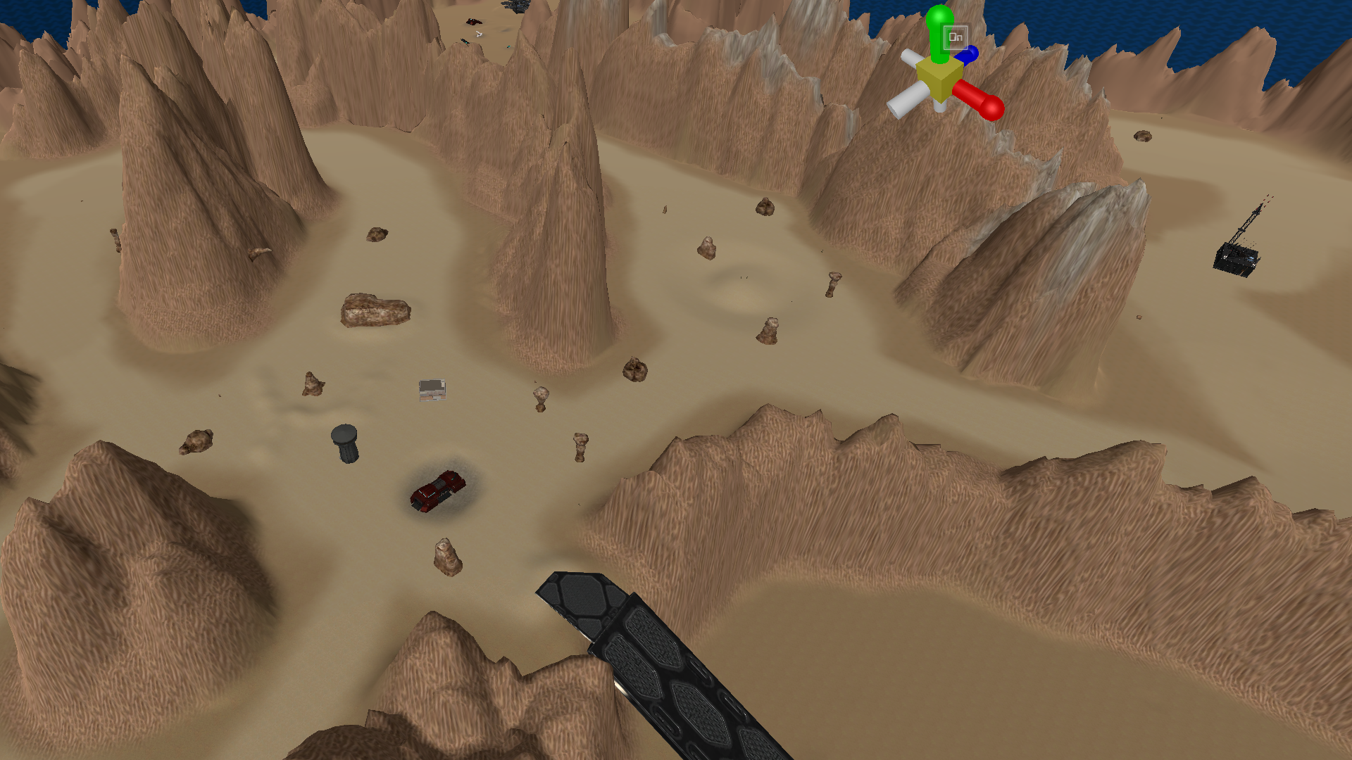

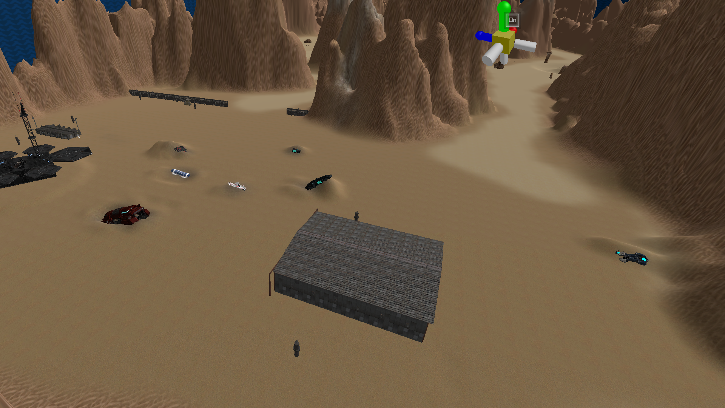

Update for 2/5/21:

* Reorganized buildings part of the base in the lower right area
* Restructured abandoned town POI and working on container-heavy section nearby
* Fleshed out paths from junkyard with obstacles
* Moved bunker entrance in lower left corner further down

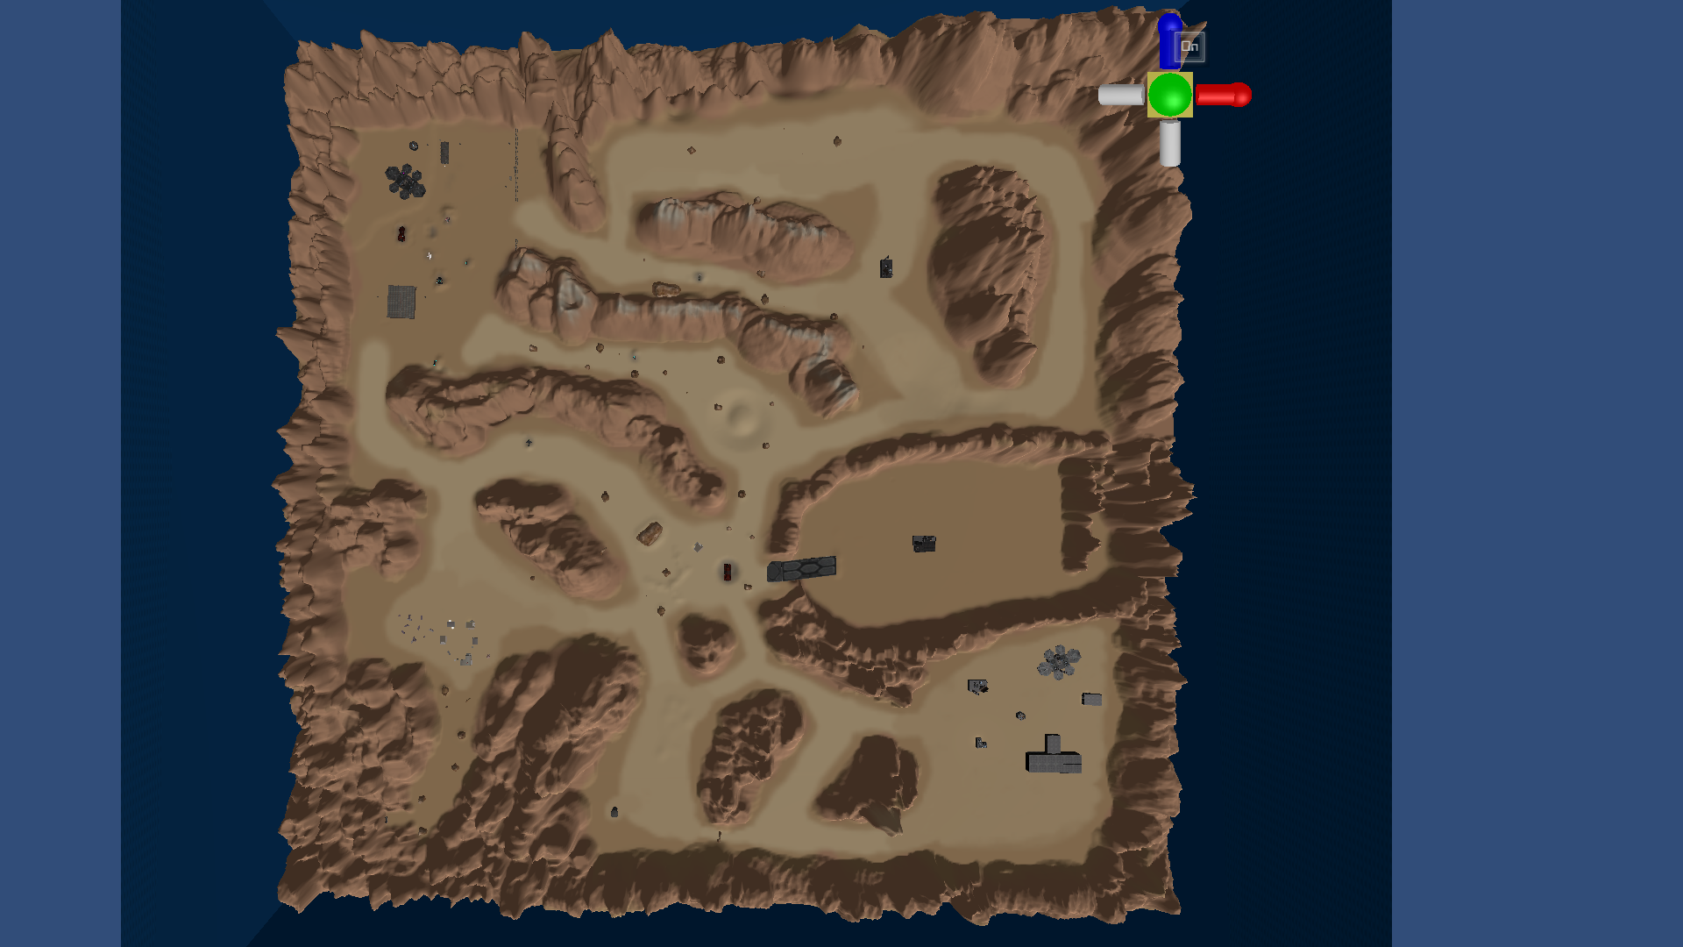

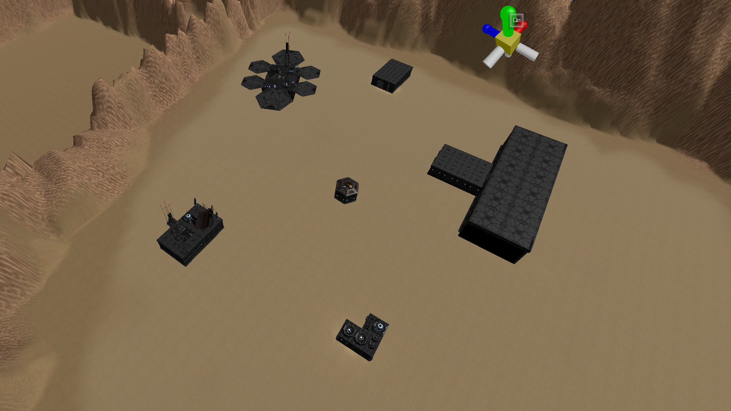

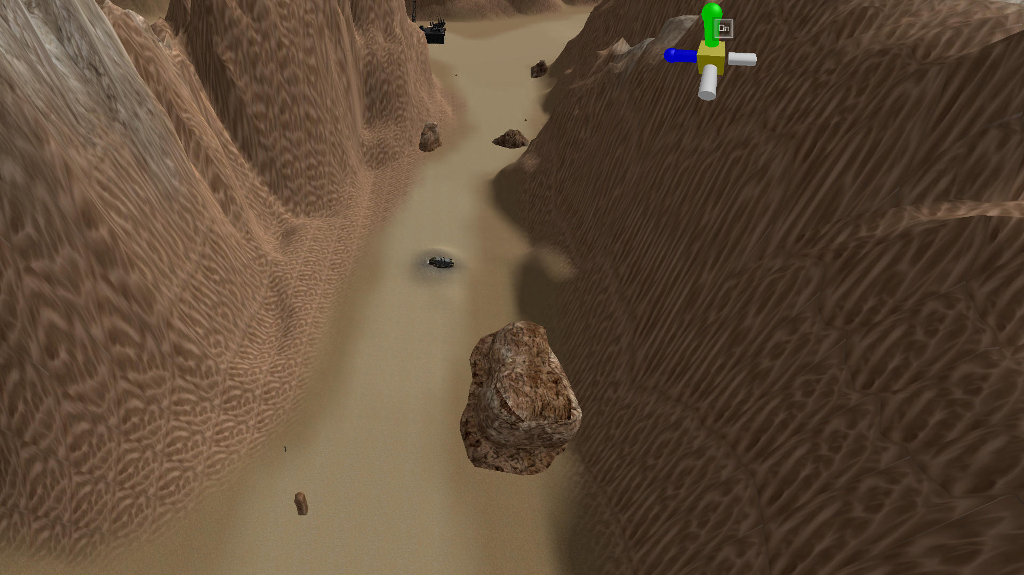

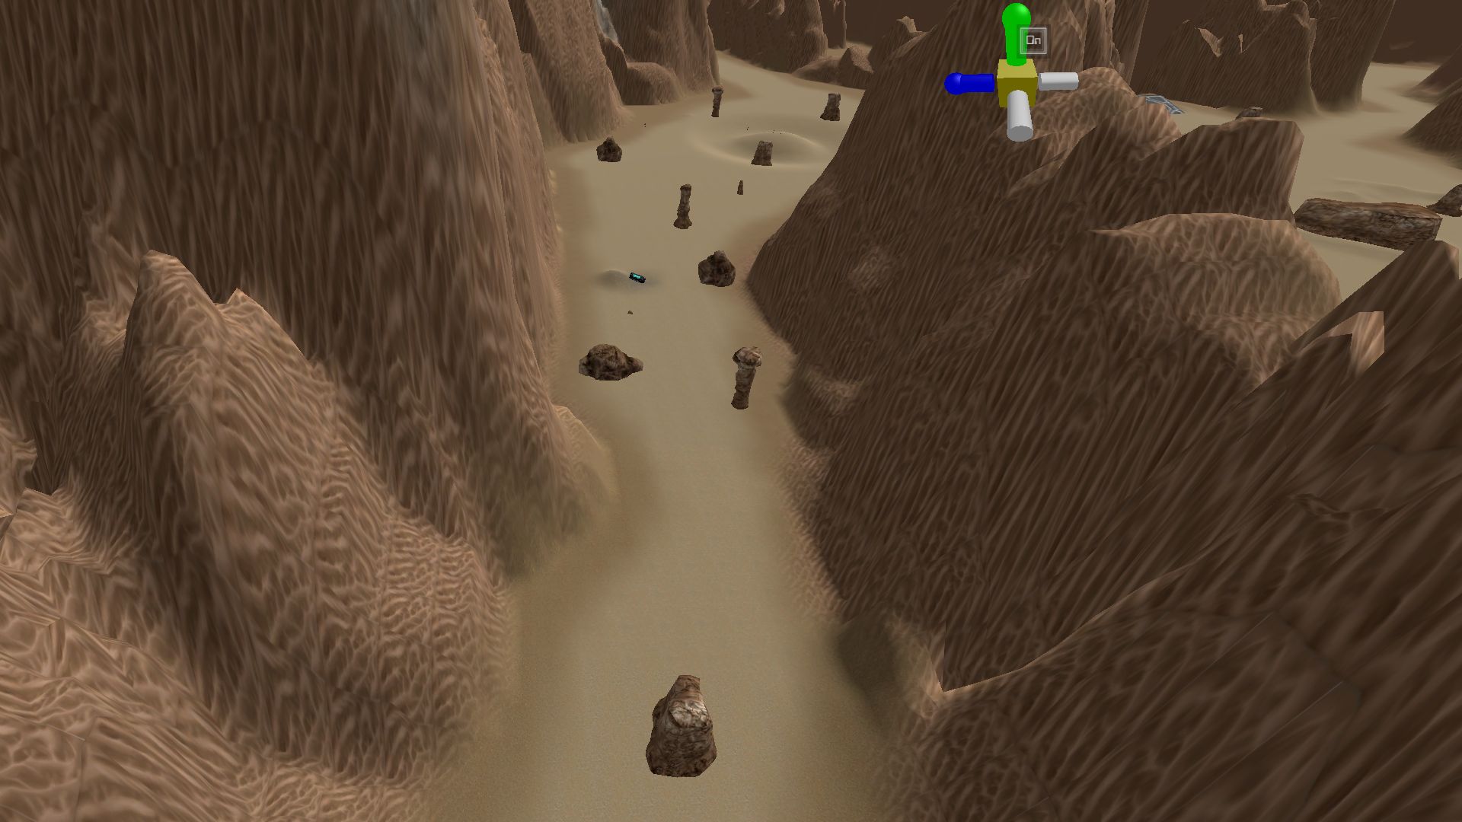

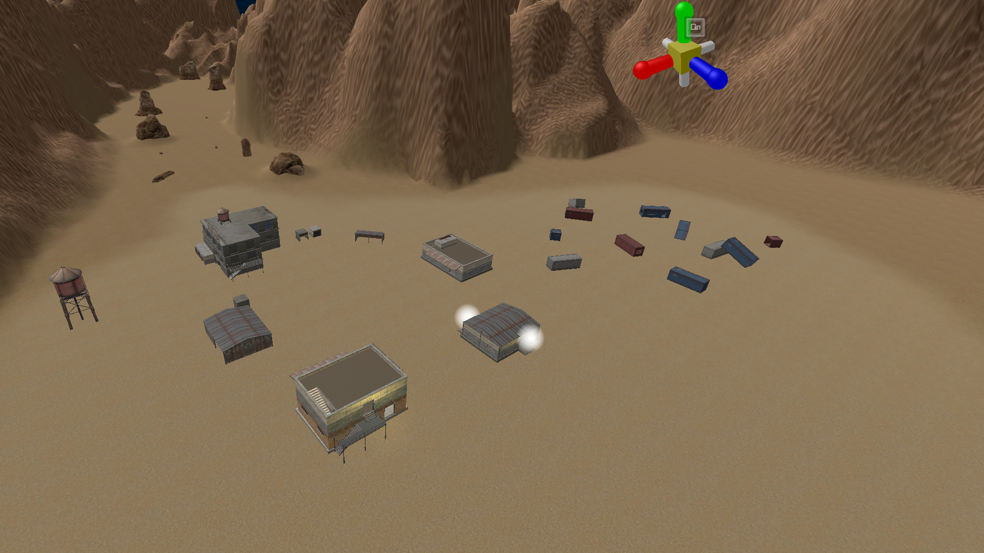

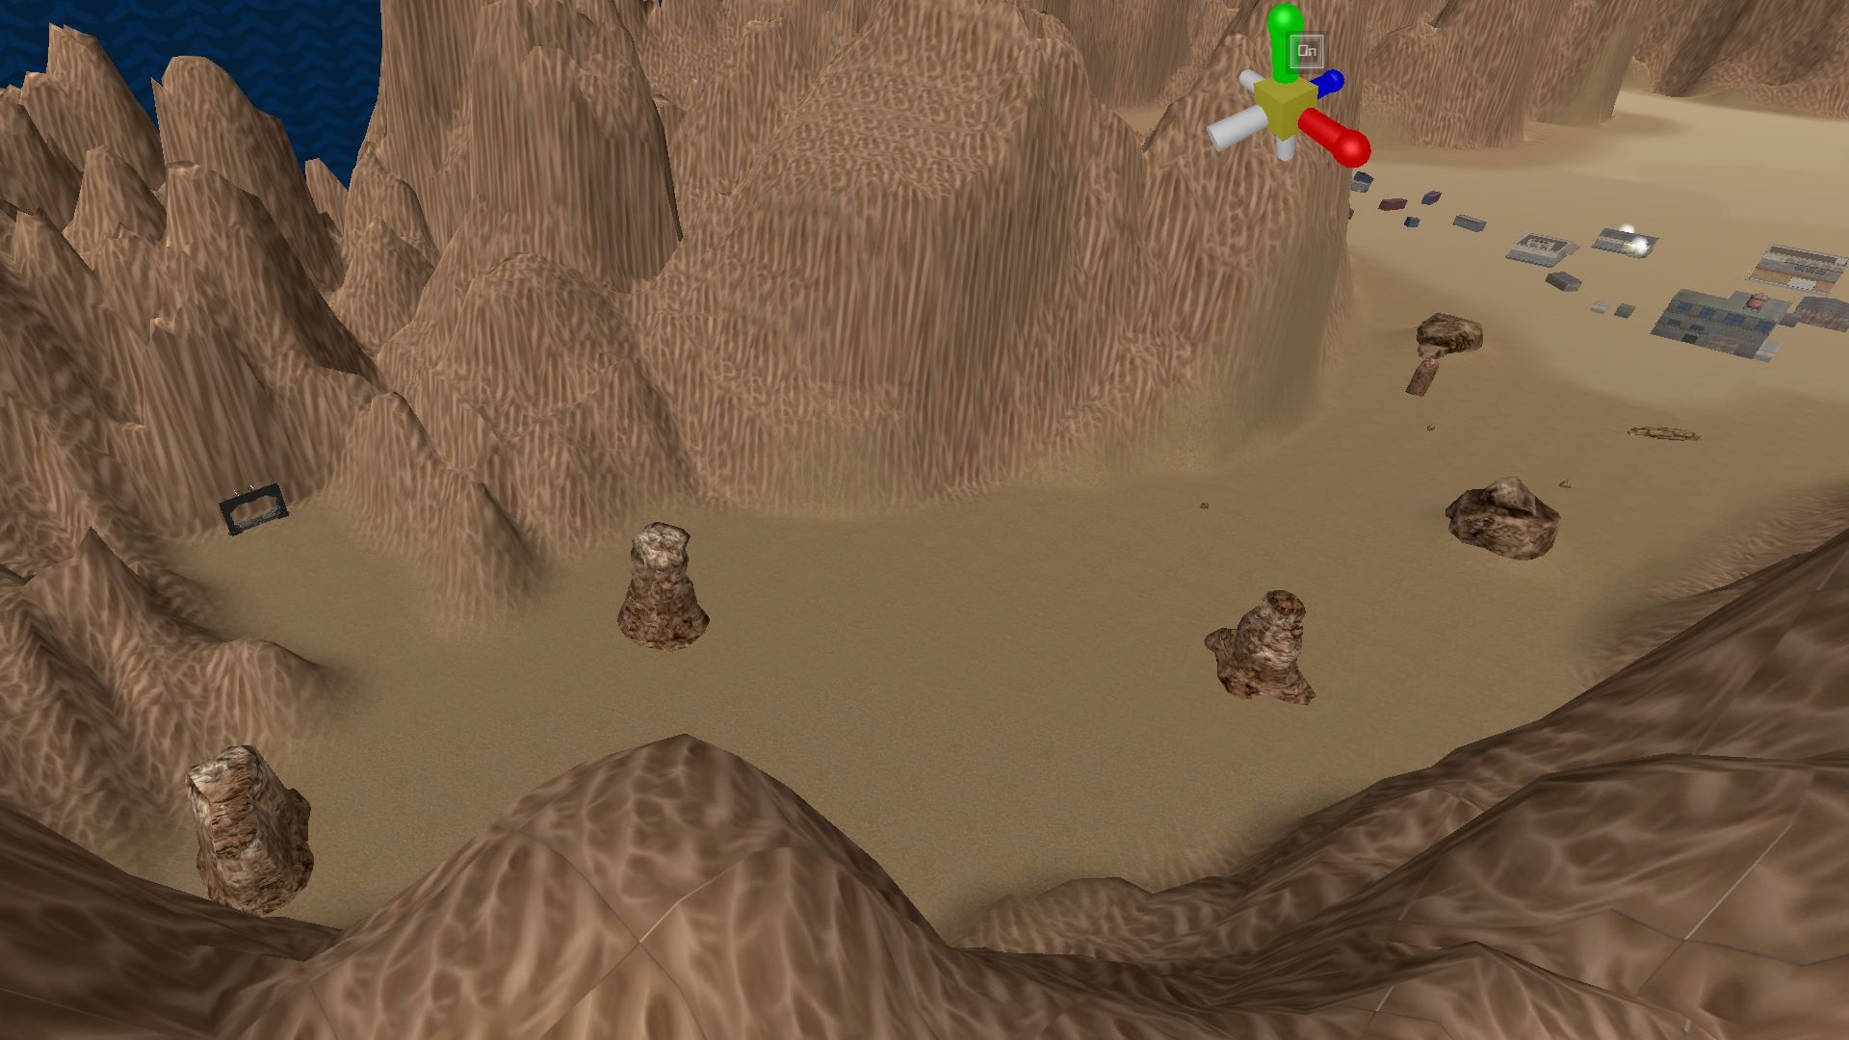

Update for 2/16/21:

* Nearly finished with abandoned settlement POI; just need to stock buildings
* Added terrain dip to closest route to abandoned settlement
* Added extra terrain obstacles to watchtower route
* Added assorted terrain assets to level

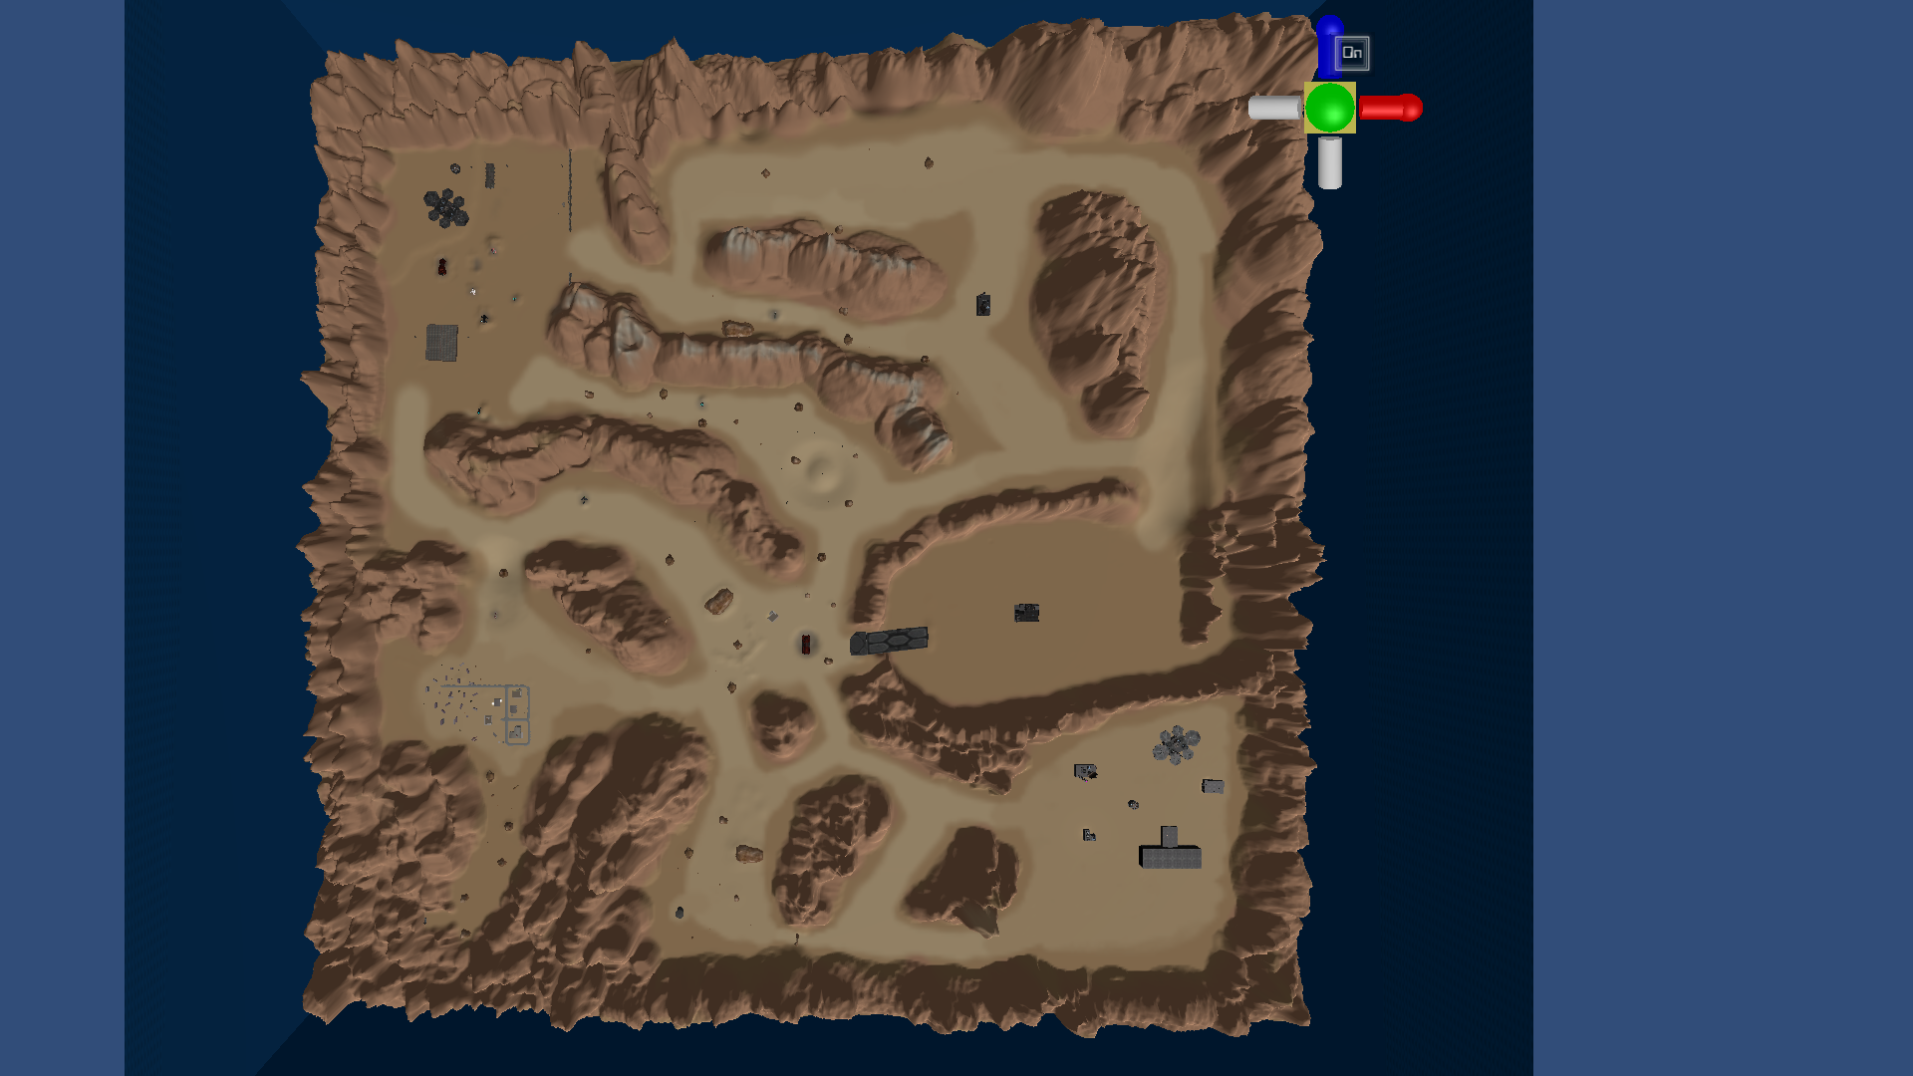

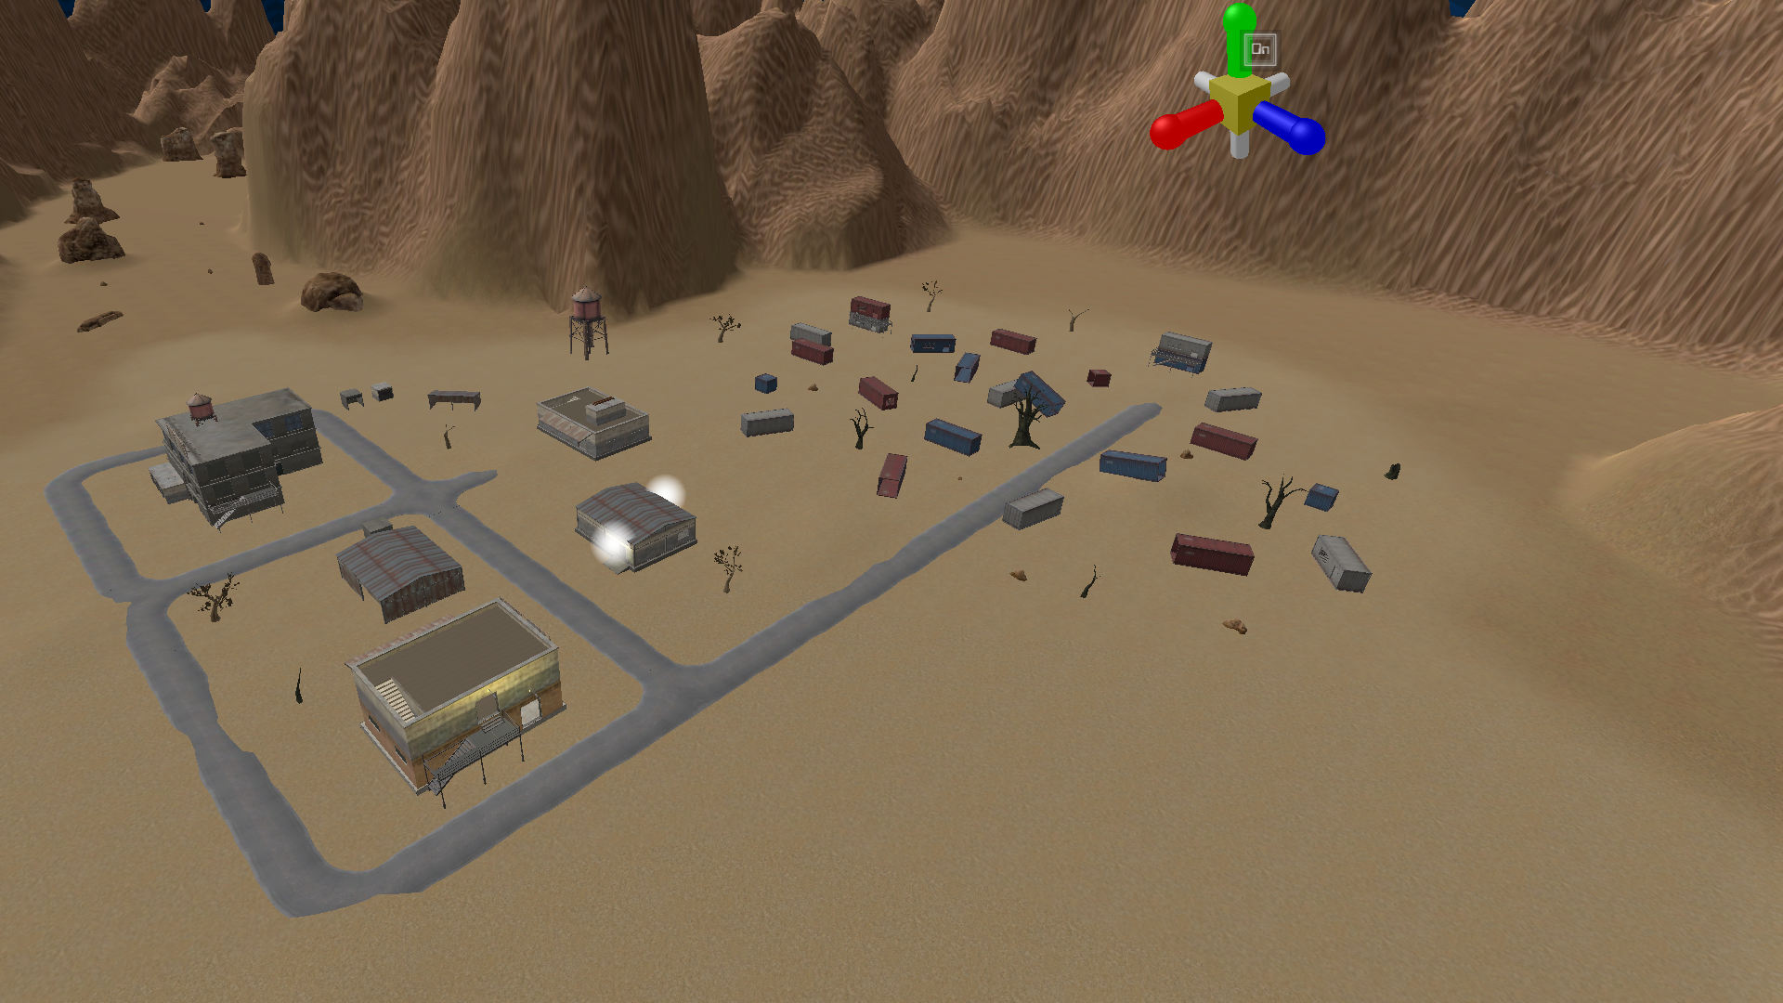

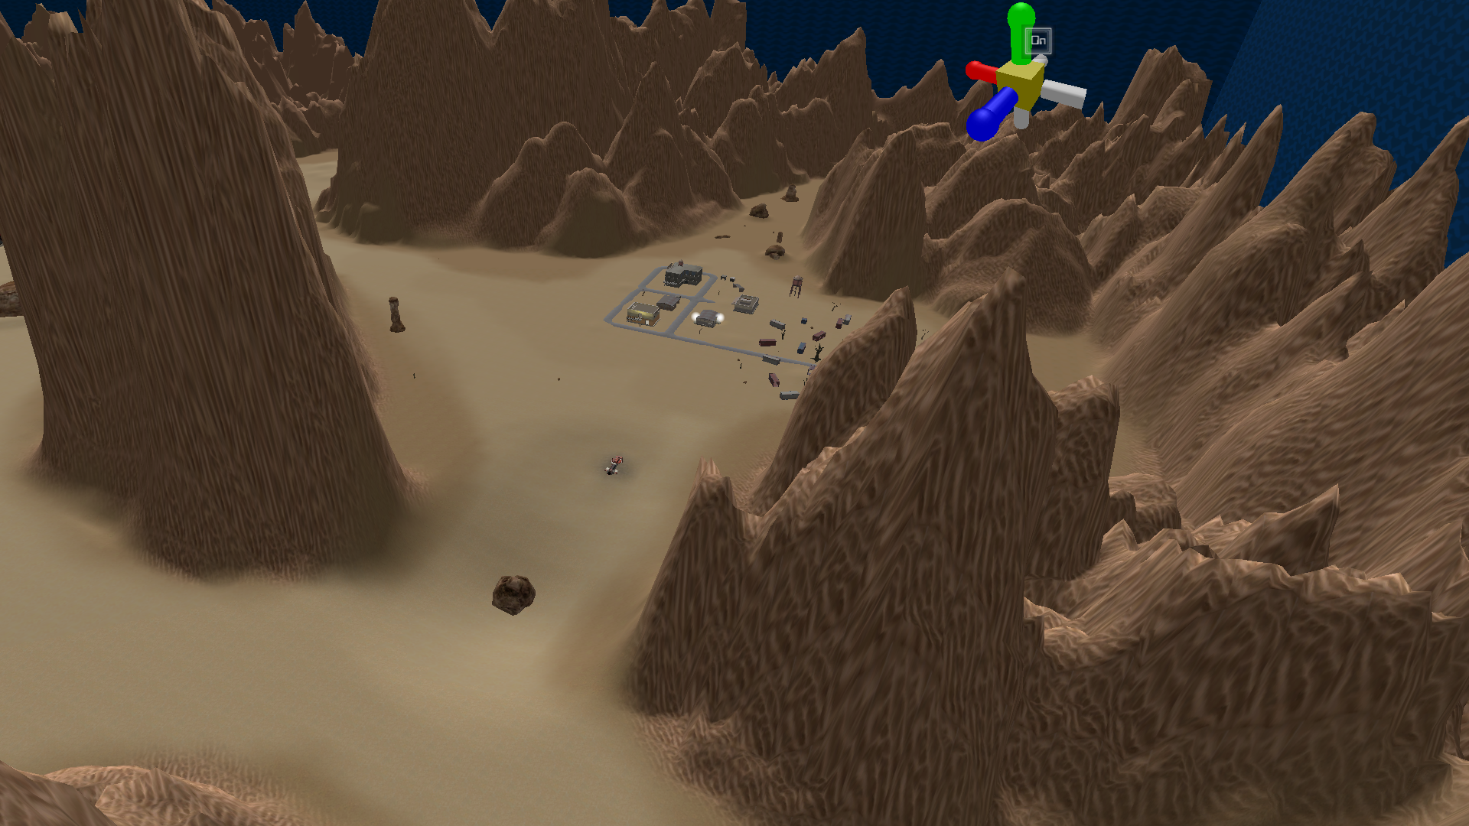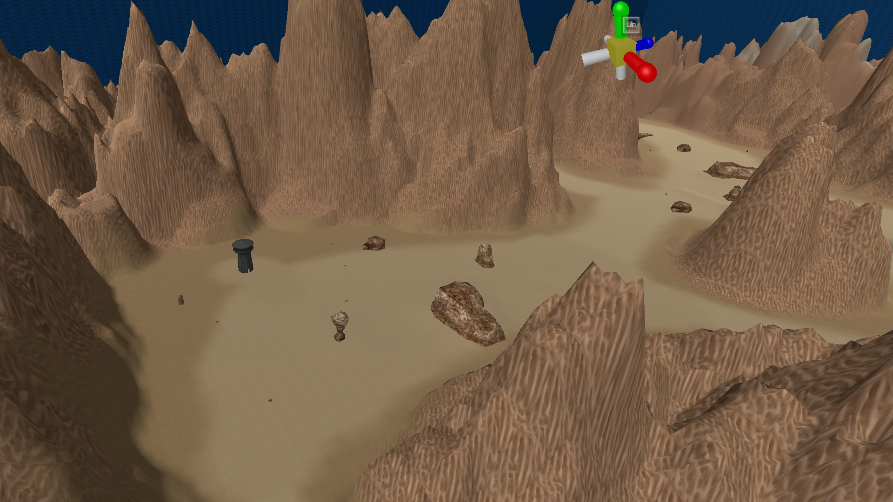

Update for 2/19/21:

* Added new route to trench
* Narrowed one of the routes from junkyard
* Finished abandoned settlement POI

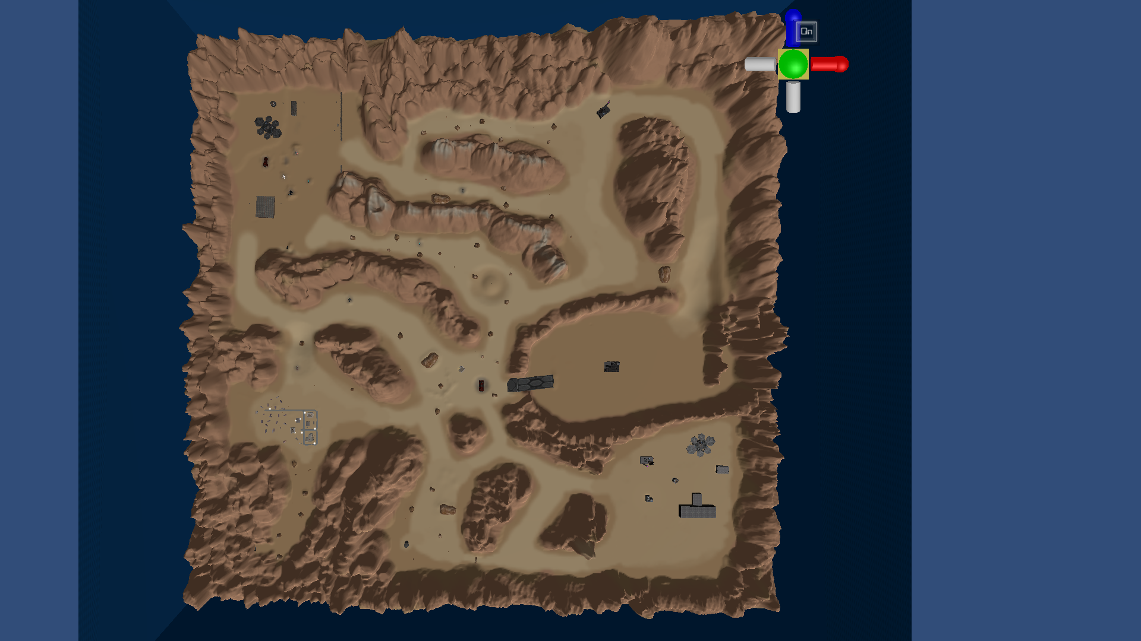

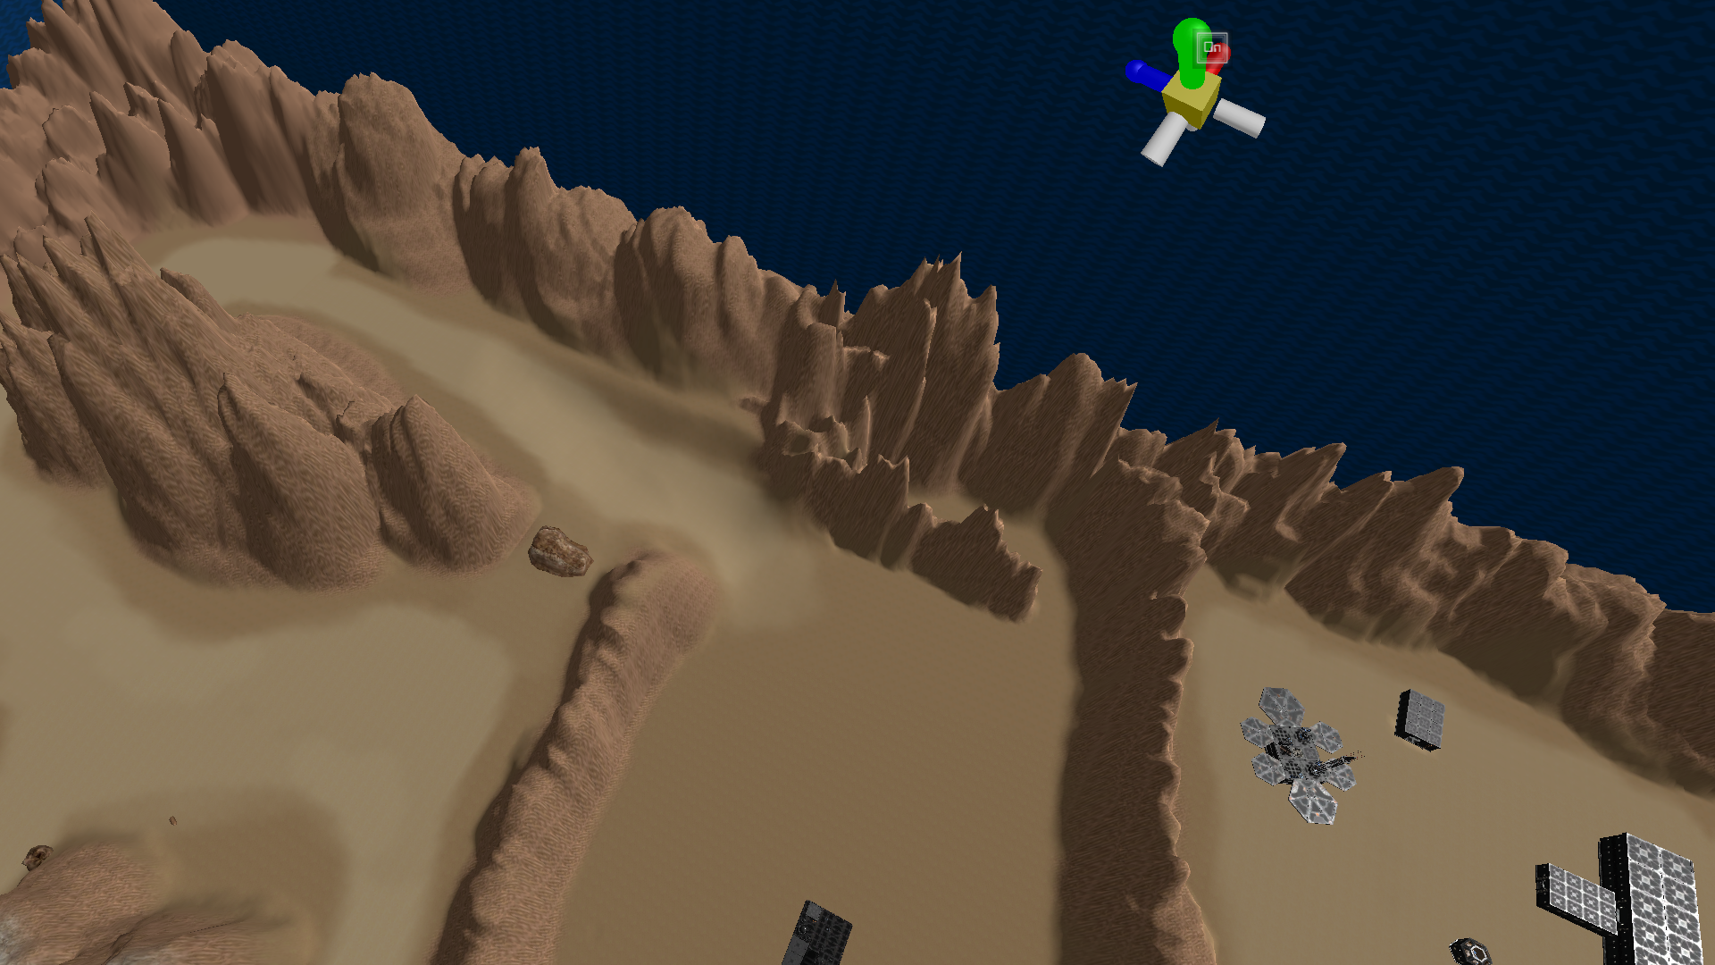

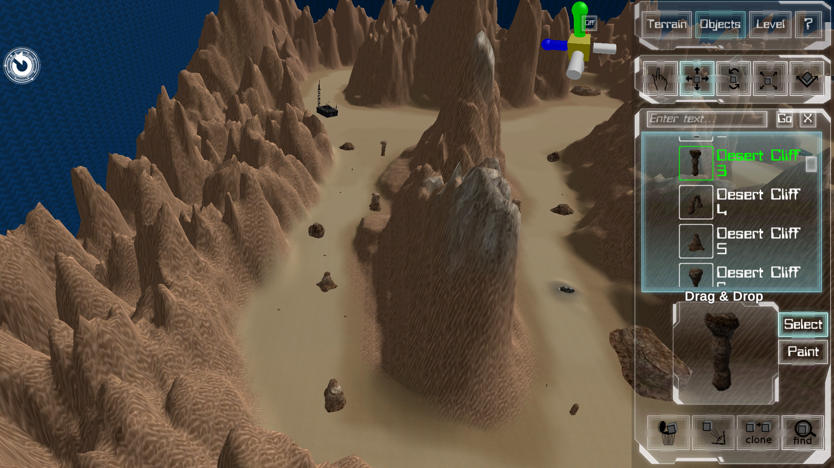

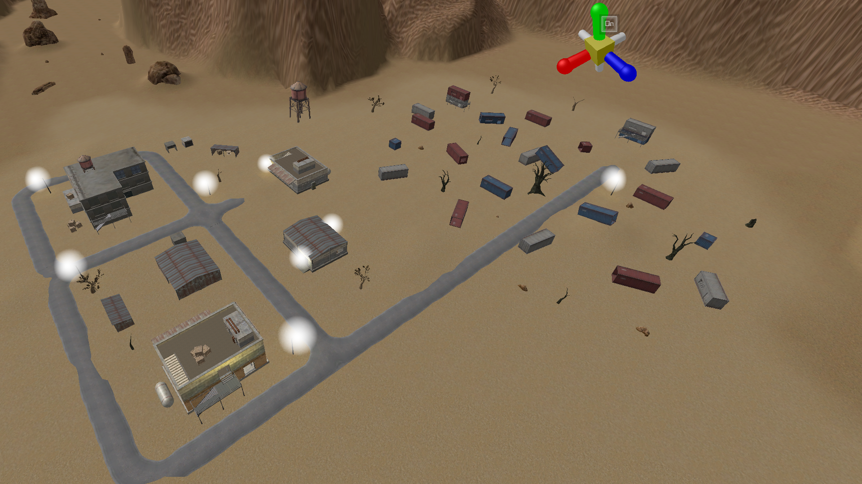 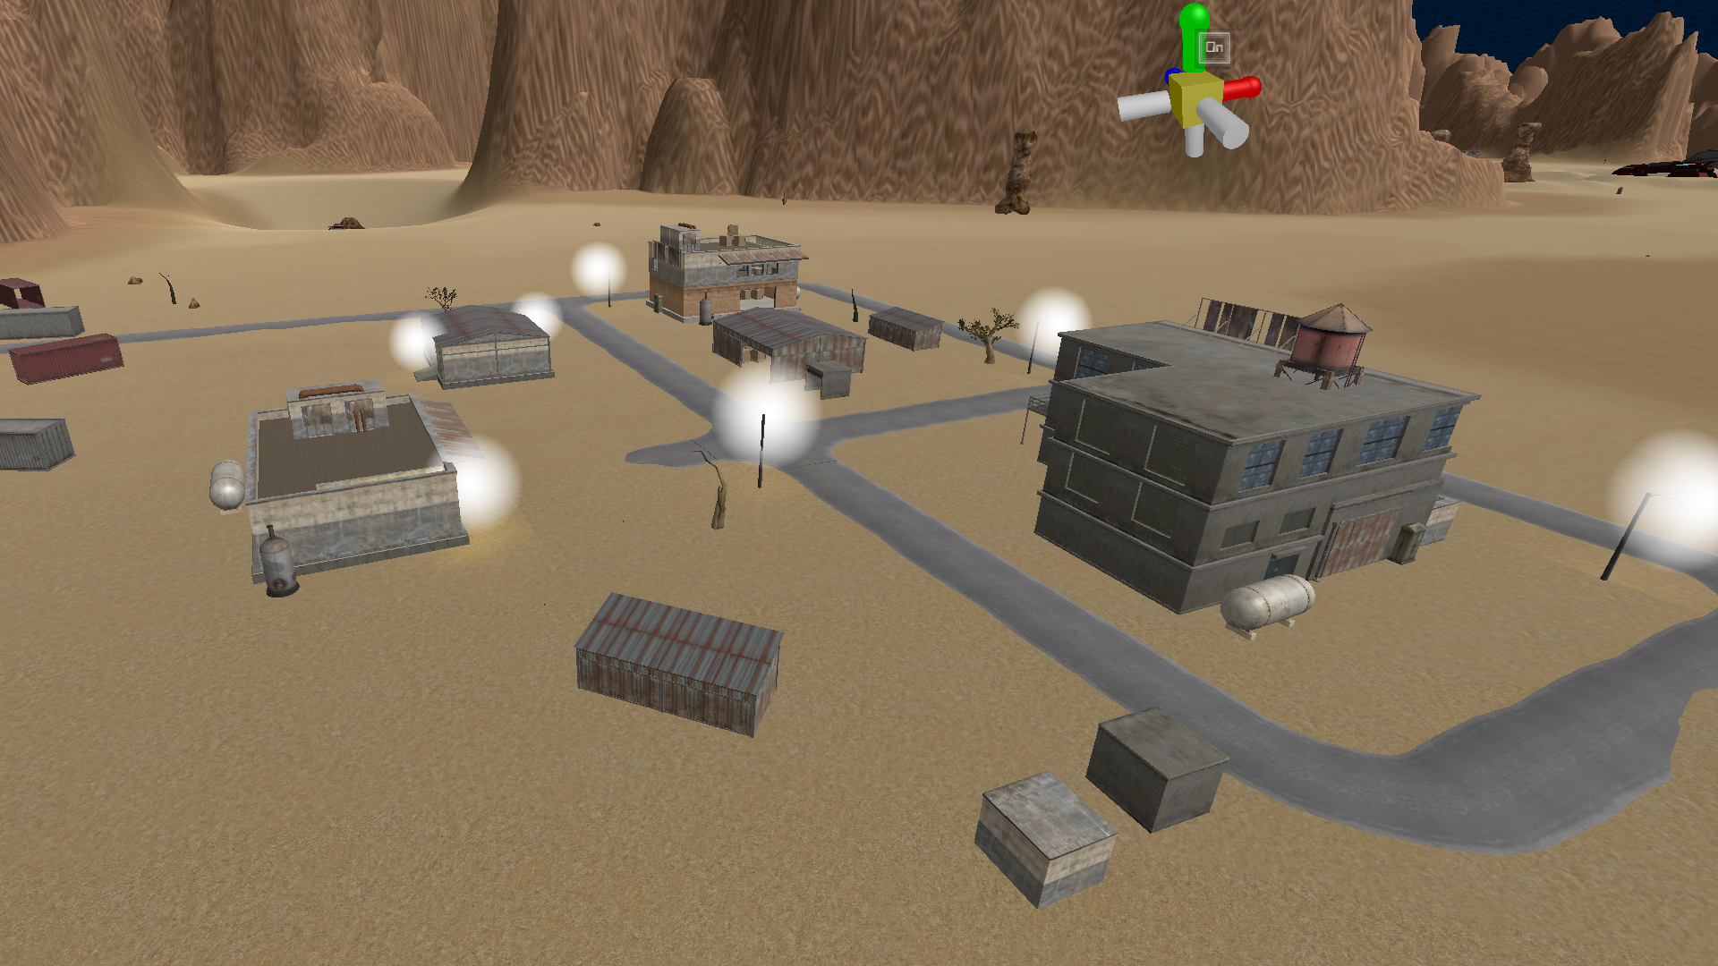 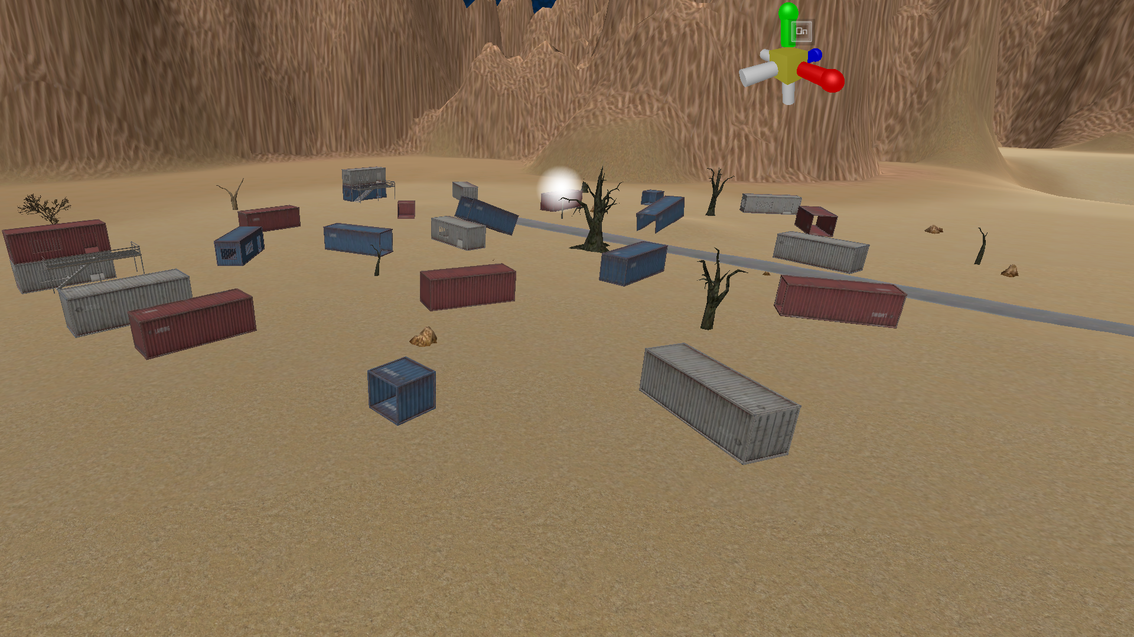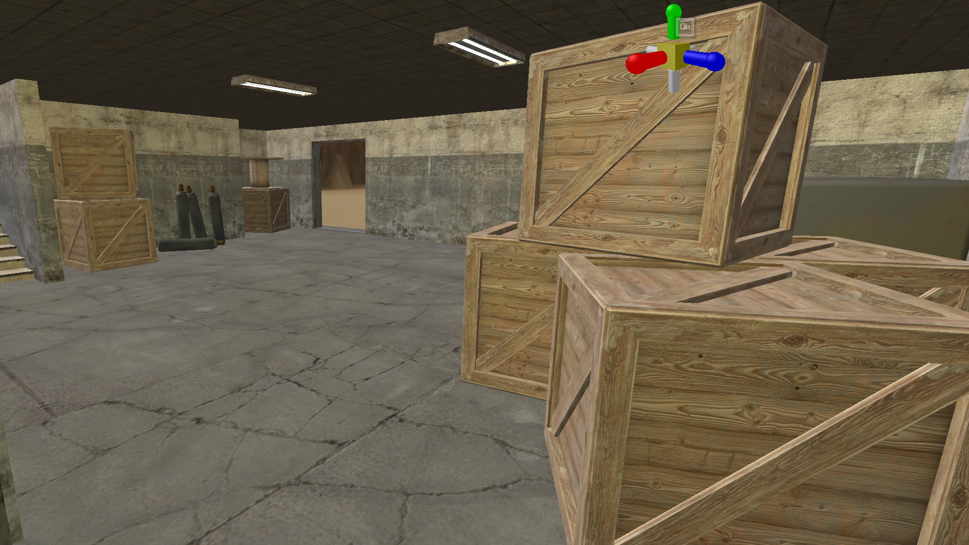

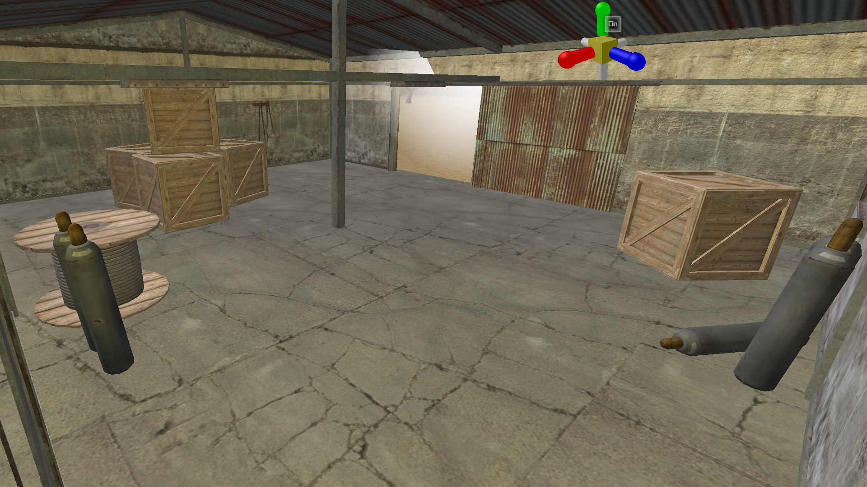 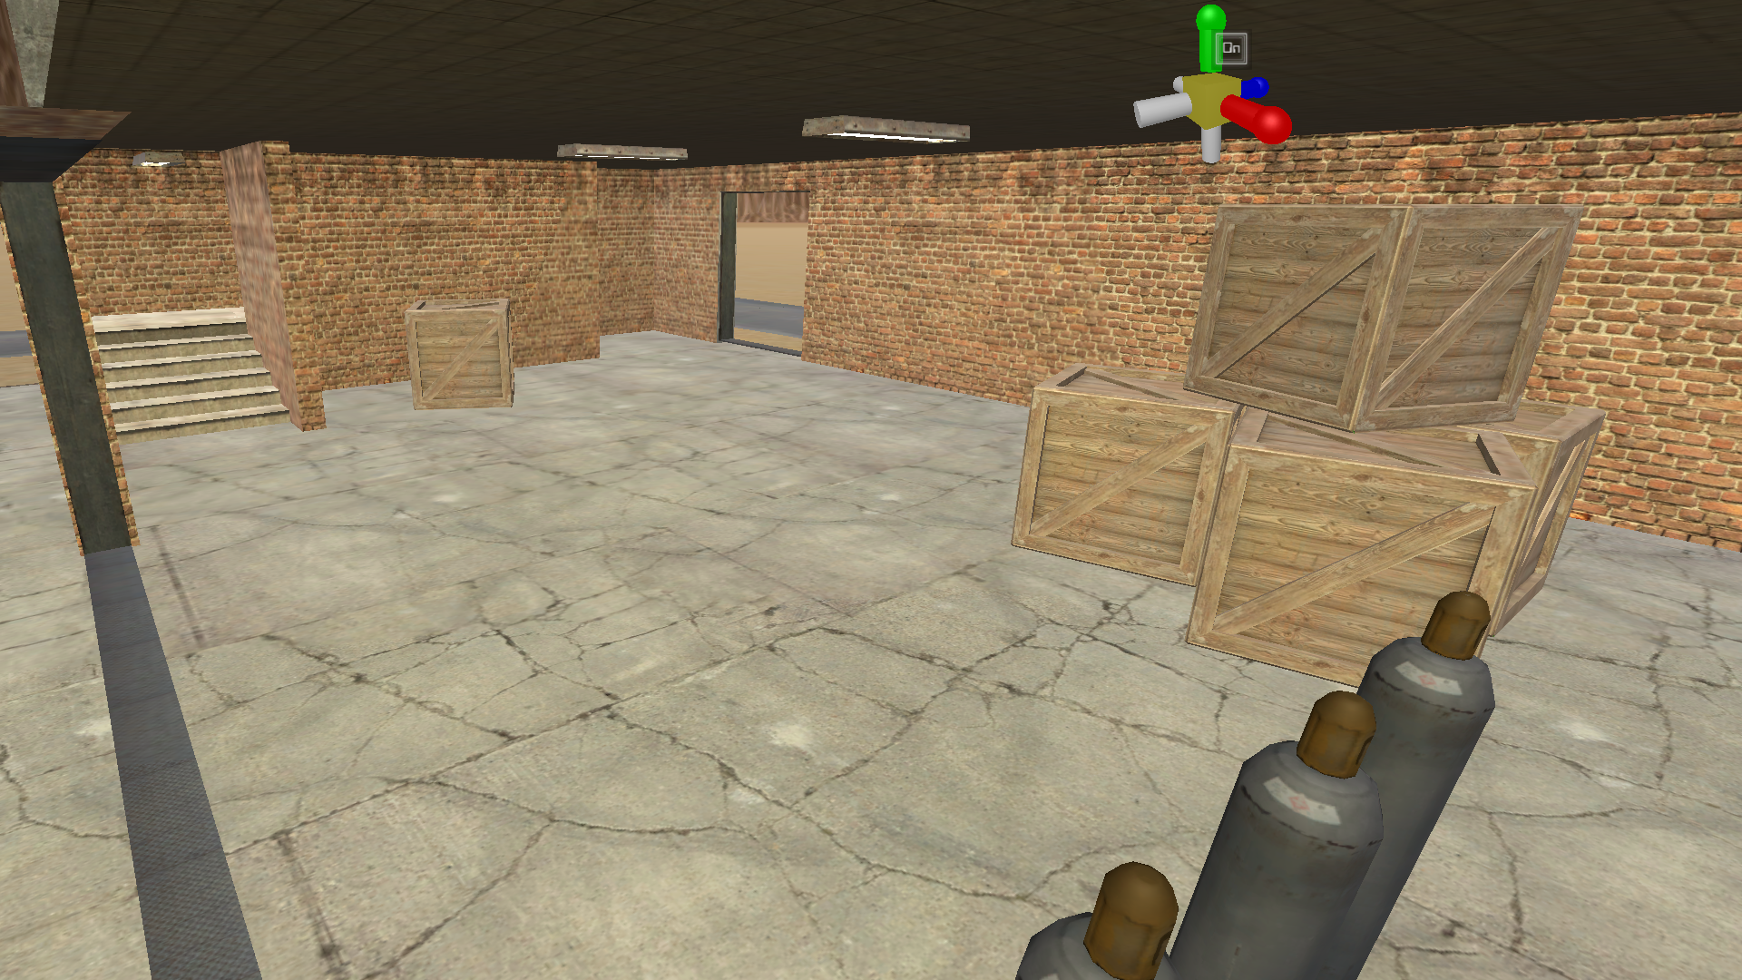 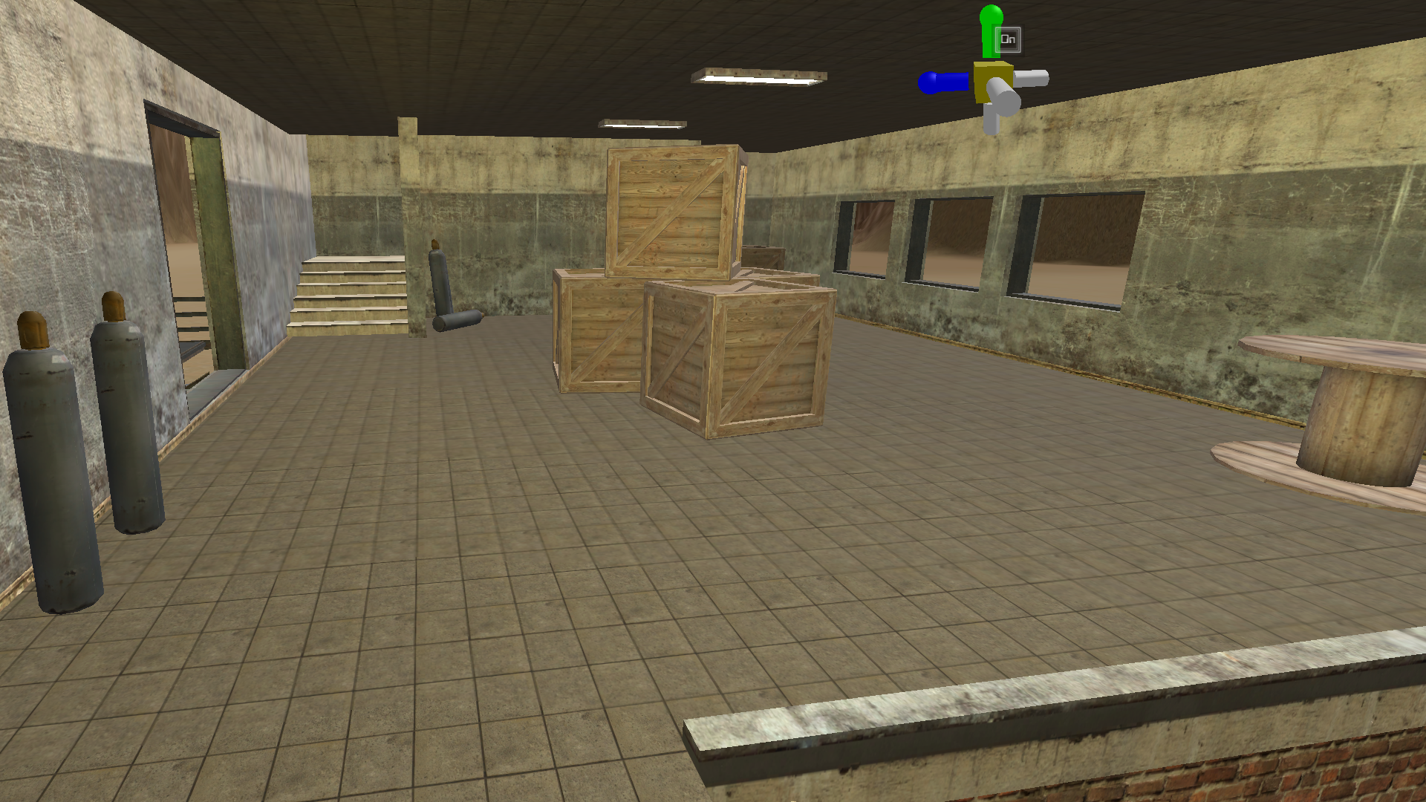 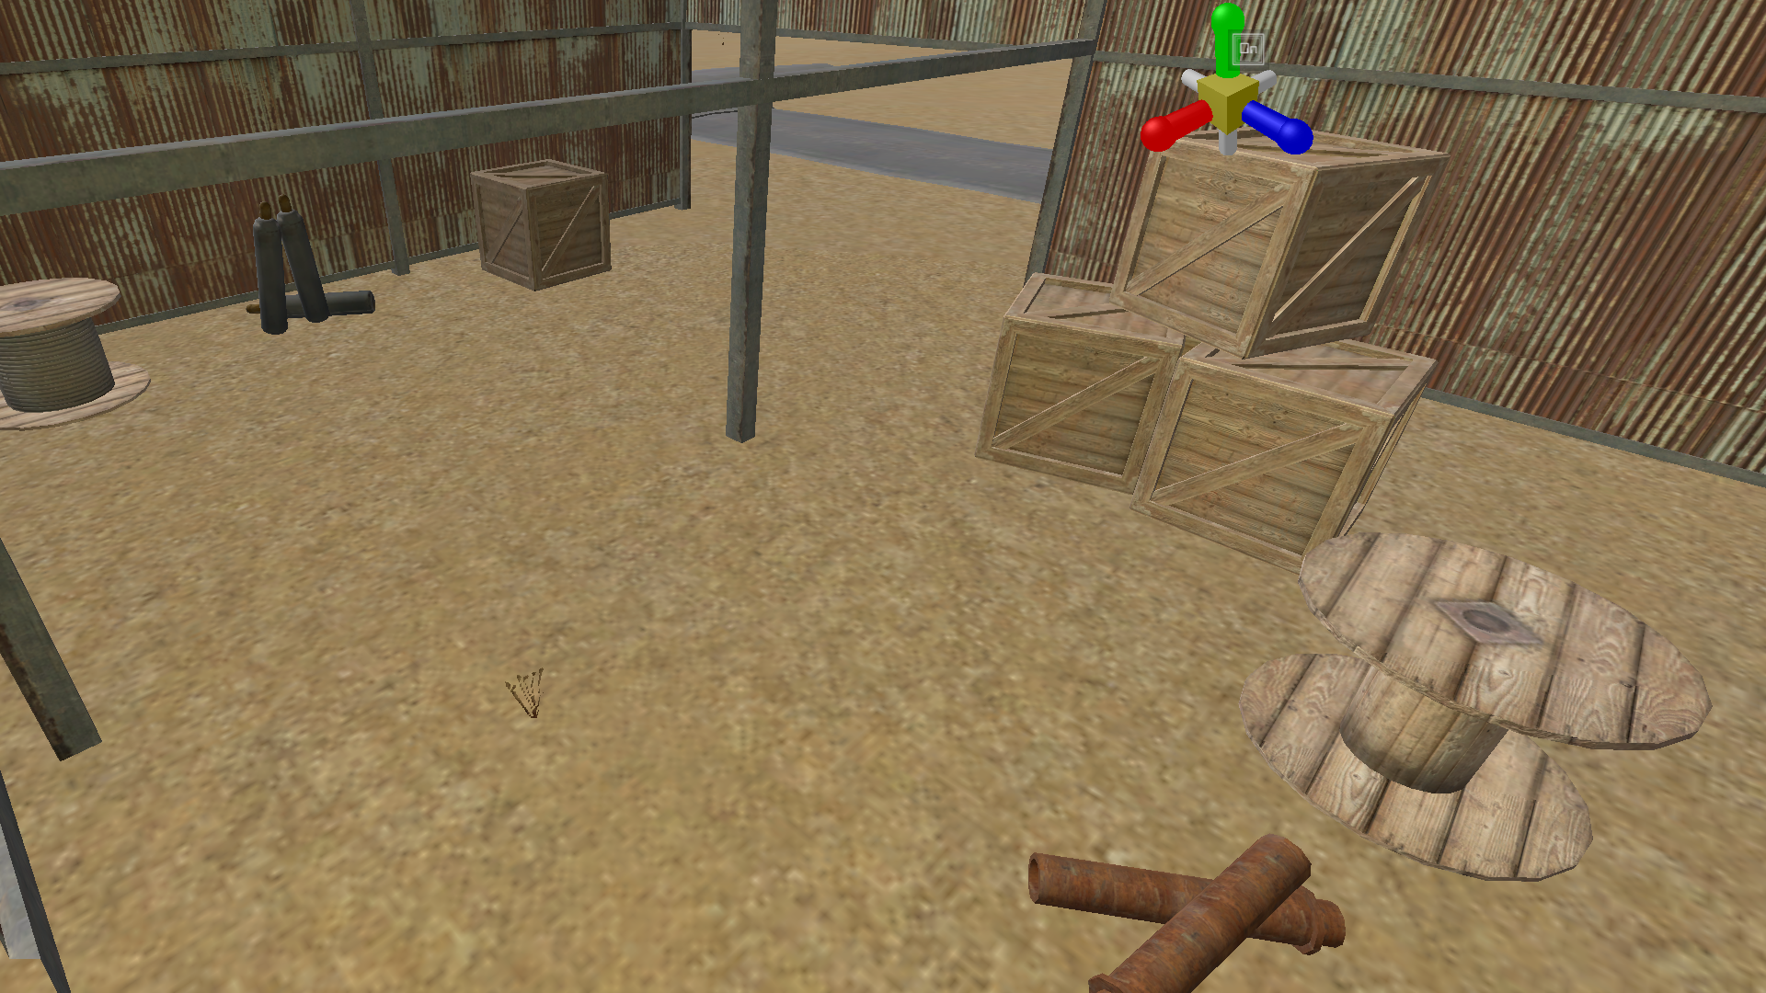

Update for 3/5/21:

* Reworked trench to better resemble real life desert canyons while adding abandoned factory to better illustrate former mining operations
* Replacing some mountains and expanding in areas
* Currently populating remaining buildings
* Polishing level

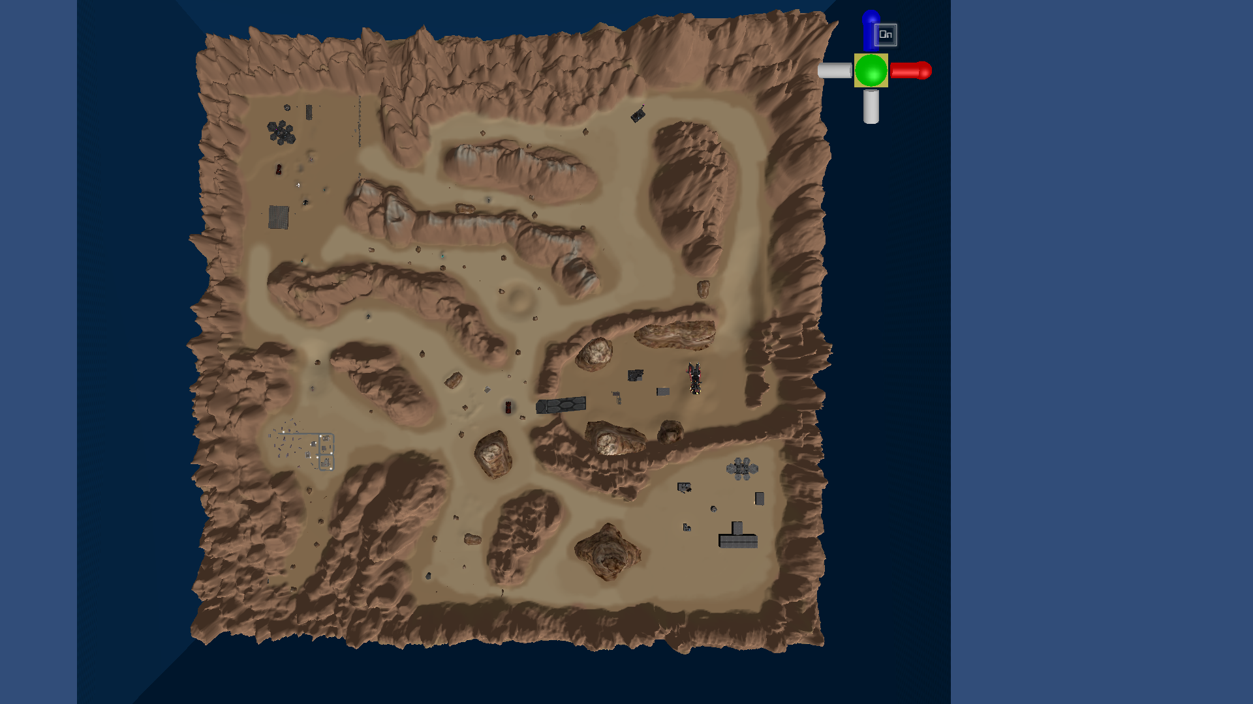

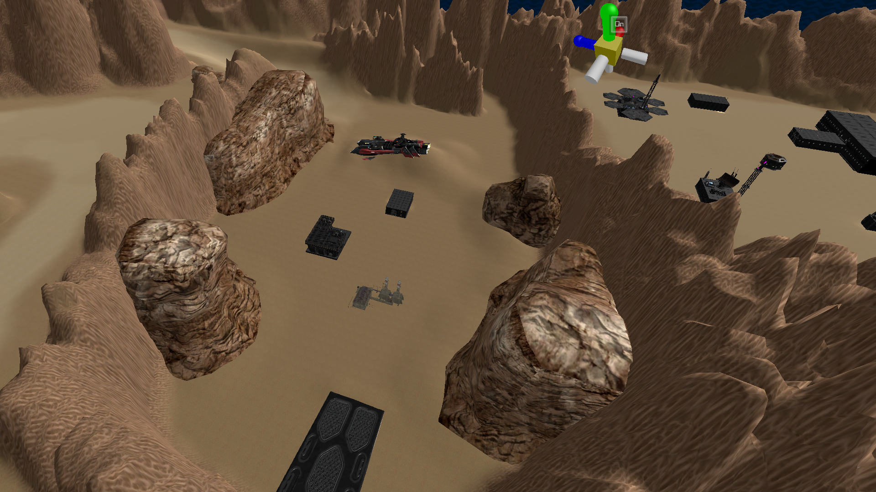

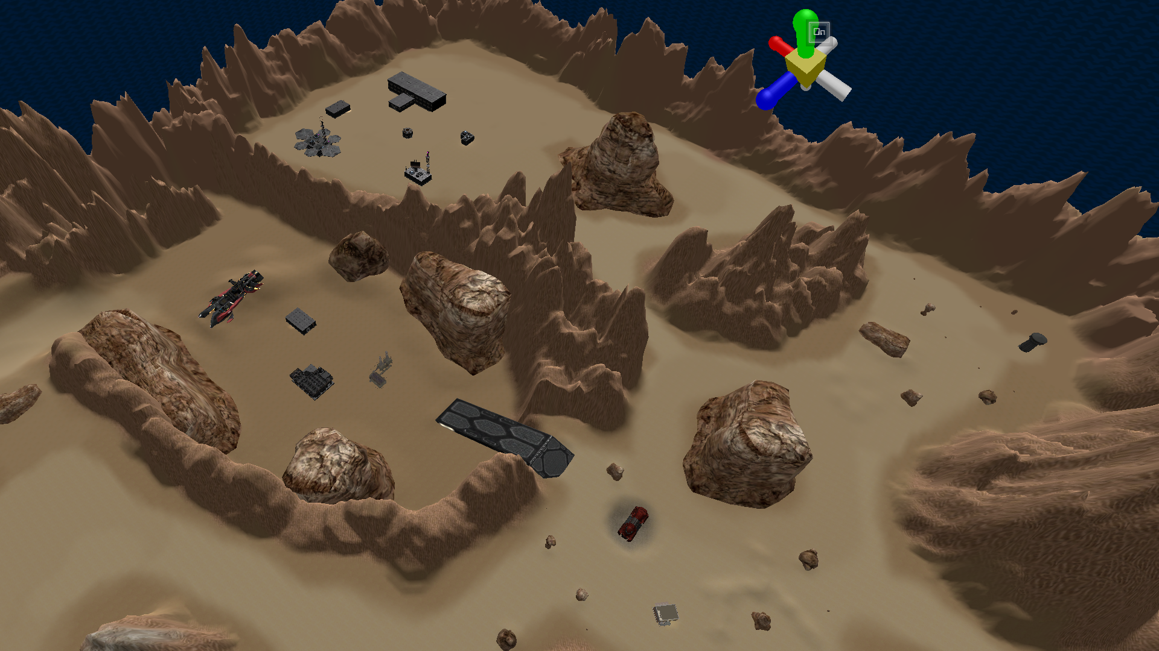

Update for 3/16/21:

* Upload final version of Cronus C1 w/ documentation

